Team 1: Nathan Elias, Neha Kamble, Ethan Ojede, Riley Parker, Joey Ross

**Advanced Computer Science Project Proposal: COVID-19 Contact Tracing**

**Objective of the Project**: LASA High School had a set of guidelines that were put in place at the beginning of the 21-22 school year that aimed to slow the spread of COVID-19. These guidelines include: mandatory seating charts, tracing “close contacts” based on proximity, vaccination status, and type of activity (i.e. PE has more potential for spreading COVID-19 as opposed to Calculus), and keeping tabs on all known positive cases through the AISD COVID-19 dashboard. This project aims to automate the close-contact tracing process through managing class layout and size data, using an algorithm to determine which students are most at risk, and visualizing the results (see Fig. 1).

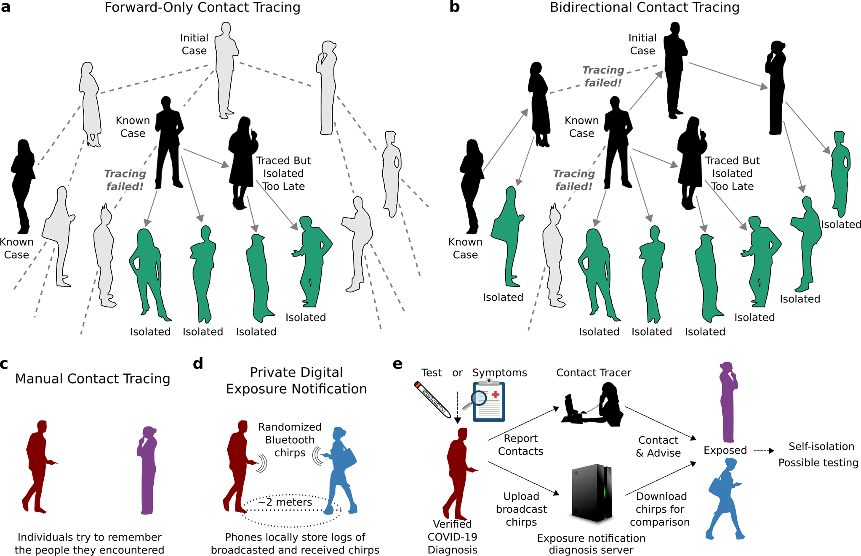

Fig. 1. Potential model/workflow for our final product. Note the creation of a tracing algorithm, as well as a server program to notify at-risk users. (Bradshaw, 2021)

**Alignment with Academic Topics in Computer Science:**

The implementation of contact tracing, specifically in the field of COVID-19 has numerous relations/alignments with academic topics in Computer Science. For example, our implementation of “COVID-19 tracing” will definitely involve the use of graphs and trees to accurately model a student’s risk of contracting COVID-19. For instance, we will use graphs to determine the direction of transmission, the potential and risk of each person exposed to the virus, and how people who may have been unknowingly infected may have spread COVID-19 themselves (see Fig. 2).

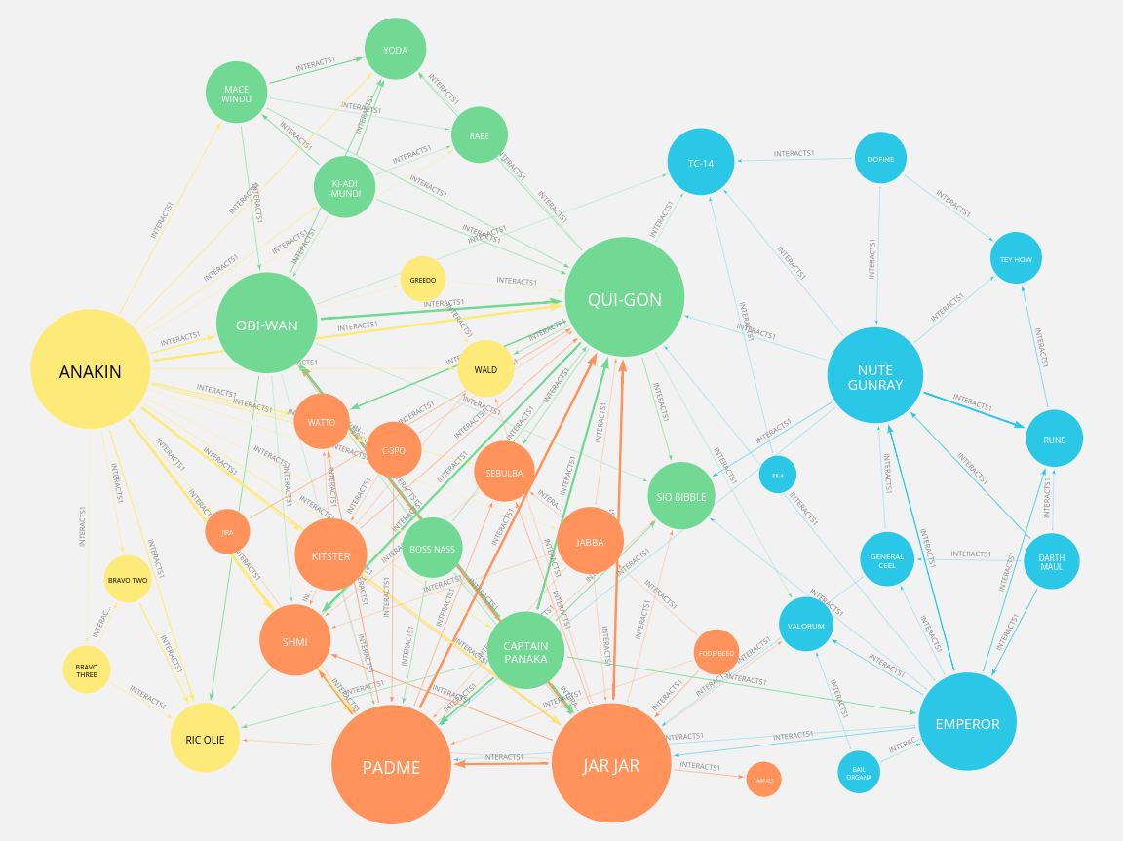

Fig. 2. Although involving Star Wars™, this graph clearly shows how the data structure can easily model contact tracing/interactions between infected/non-infected people (“Contact Tracing Tree Diagram”).

Additionally, the use of the tree data structure will be pivotal in our modeling of infected individuals to non-infected individuals. For example, the use of b-trees to create “tiers” of COVID-19 vulnerability will be essential, as well as using the “root node” of trees as an infected individual to better visualize/model the spread of the pathogen (see Fig. 3).

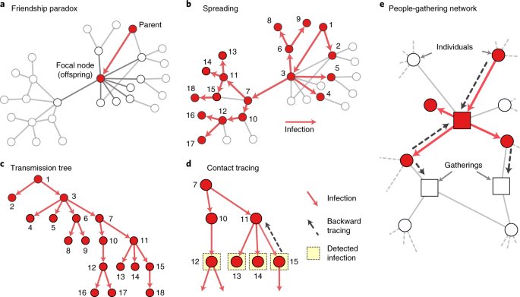

Fig. 3. Visualization of the potential use of trees in modeling disease spread and overall contact tracing. (“Contact Tracing Tree”)

Furthermore, other than the use of graphs and trees, the project will extensively require the use of data processing skills as well as user-interface creation and server-side programming. As the Covid-19 data will be formatted into a CSV file, which will be compiled from a cloud-based form, thereby involving the concepts of Cloud Computing and Web and Information Retrieval. Lastly, the creation of a user interface, in which a CSV file of students/infected people is uploaded to a website, resulting in emails sent to people at risk (via a server) clearly also involves the topic of servers and server-side programming as well. All in all, this project involves the use of academic computer science topics like graphs, trees, cloud computing, web and information retrieval, user interfaces, and server-side programming.

**Roadmap / Milestones:**  
The project is split into three main sections: data collection and processing, algorithm development, and web display and visualization. We will work on these sections in parallel to get constant feedback about them and for efficiency. As we develop the final product, each of these sections will have specific milestones that we can then use to measure overall progress.

Data Collection and Processing:

* Form created with input fields of classes attended, nearby students, age, vaccination status and recent reported COVID-19 tests.
* User input data is added and organized into a CSV file
* CSV file can be accessed by algorithm development team and structure can be easily implemented into algorithm

Algorithm Development:

* Gets data from CSV file
* The algorithm will use b-trees and huffman encoding (to determine COVID-19 risk based on proximity) based on class layout.
* The result of the algorithm will be sent to a Website to be displayed.

Web Display and Visualization:

* Includes input form links to csv file
* Displays list of people most likely at risk
* Automated email sent to those in close contact

**Outcome / Assessments:** The main outcome for this project is to have an easier way of understanding COVID-19 tracing and allow for anyone to be able to understand useful utilizations of C++. The ending product will be placed on a website, to allow for easy access for anyone that needs a simple way to understand COVID-19 tracing. To help further this project along, we will implement End- User tests to see if the ending product can be used by people of varying needs (Ex: a principal should have different requirements that needed testing than a student). We will also implement periodic unit tests to help maintain the crucial parts of our algorithm. Those would include mostly tests on specific functions in the code but we will also use them to test combined- functions together to make sure that they can implement each other correctly. We also plan on using black- box tests (tests only looking at inputs and outputs without looking at code), to make sure that our code should be returning what the user should expect.

Works Cited

Bradshaw, William J., et al. “Bidirectional Contact Tracing Could Dramatically Improve COVID-19 Control.” *Nature Communications*, vol. 12, no. 1, 11 Jan. 2021, 10.1038/s41467-020-20325-7.

*Contact-Tracing Tree*. media.springernature.com/m685/springer-static/image/art%3A10.1038%

2Fs41567-021-01187-2/MediaObjects/41567_2021_1187_Fig1_HTML.png. Accessed 11 Apr. 2022.

*Contact-Tracing Tree Diagram*. dist.neo4j.com/wp-content/uploads/20200430233953/1_f2MtjQg0_vS2aHqLhqEOTQ.png. Accessed 11 Apr. 2022.

Crescenzi, Stacia. "Principal's Message 09-06-2021." Principal's Message, LASA Webmaster, 6 Sept. 2021, docs.google.com/document. Accessed 11 Apr. 2022.

Gloag, David. “What Is End User Testing? - Definition & Acceptance | Study.com.” *Study.com*, 2021, study.com/academy/lesson/what-is-end-user-testing-definition-acceptance.html.

Guru99. “What Is BLACK Box Testing? Techniques, Example & Types.” *Guru99.com*, 2 June 2019, www.guru99.com/black-box-testing.html.

Kojaku, Sadamori, et al. “The Effectiveness of Backward Contact Tracing in Networks.” *Nature Physics*, 25 Feb. 2021, 10.1038/s41567-021-01187-2